Simplifying the finite difference method in structural analysis
A A Adedeji

With the method of finite difference we can always assume the use of Laplace and Poisson equations from the theory of torsion, that can be obtained by the derivation of differential equation in algebraic form.. This results to system of linear algebraic equation. It is assumed, as shown in Fig.1, that difference Δ = Δx = Δy. From the first two derivations, the following equations hold:

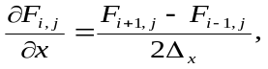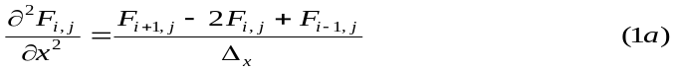

As well as,

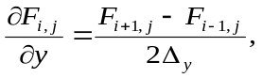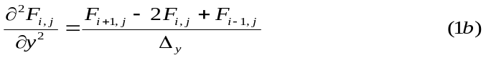

From the above equations we can obtain to higher derivation and as shown in Fig.1, the second derivation can be defined along x-axis as:

equally along y-axis.

For higher derivation:

equally along y-axis.
Δ_{x} Δ_{x} = Δ

i, j+2

i-1, j+1 i, j+1 i+1, j+1

Δ_{y} = Δ
i-2, j i-1, j i, j i+1, j i+2, j

Δ_{y} = Δ
i-1, j+1 i, j+1 i+1, j-1

y i, j-2
x

Fig 1 Differential points from node (i,j)

An elementary calculation gives the following equations:

Likewise:

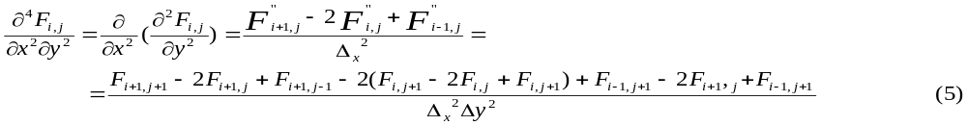
By the use of derivation we can establish differential substitutions for a differential equation, ie biharmonic equation:

ΔΔF = 0 (6a)

Simplifying, it can be assumed that step difference is found in both directions for Δx = Δy= Δ. In a such condition we can obtain the differential equations:

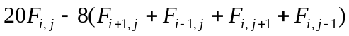 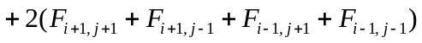+
Equation (6b) corresponds to the points in Fig.2. If assumed a rectangular element, differences is taken for all the internal points of the element, where we can obtain 12 linear algebraic equations with the unknown functions F₁ to F₁₂. This include all the boundary and internal nodal points

Δ_{x} Δ_{x} = Δ

1

2 -8 2

Δ_{y} = Δ
1 -8 20 -8 1 = 0
Δ_{y} = Δ
2 -8 2

1
y
x

Fig 2 Factors for nodal functions

F

The element boundary values of Fx are calculated by boundary conditions. This clearly has been expressed in Fig. 3 for vertical plain object, so that at side AB, function FA is obtained by the help of the values of the internal nodal points. Along AB, the following relationship holds:

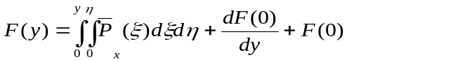 (7a)

And the second condition of such function along the x axis perpendicular to the boundary side is expressed as:
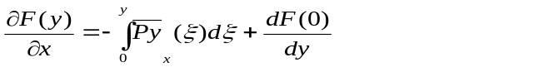 (7b)
span
A
¯P_{y}

¯P_{x}
y
x B
Fig. 3 boundary conditions

The same method is applied to other boundaries.
Integration constants are:
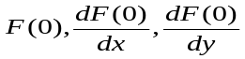
As in equation (7), the each of the 2 sides must be chosen
so the joint functions are secured for the two derivation
of function stresses. The course of derivation of function stresses is obtained with respect to x, so that by its substitution, we can now write, deriving from equation (1) referring to Fig. 4, that:

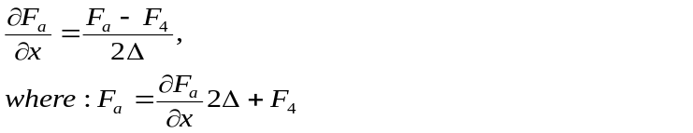 (8)

The same method is applied to the remaining boundaries.
Δ Δ

A

F₁ F₂ F₃ F₄ a F_{a}

F₅ F₆ F₇ F₈

F₉ F₁₀ F₁₁ F₁₂

B
y

x

Fig 2 Factors for nodal functions

After the boundary(end) conditions are fulfilled, the basic equation (6b) becomes homogenic which we can now solve so as to obtain values of the functions of all the internal points. Components of stresses can be computed from the following equations:

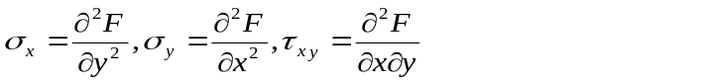 (9)

